Product Category | RF Coaxial Connector
Connector Type | Board Mount
RF Series | SMA
Interface Type | Inner hole
Number of Ports | 1
Impedance | 50Ω
Maximum Frequency | 3GHz
Style | Elbow
Interface Diameter | 5.35mm
Interface Length / Height | -
Operating Temperature Range | -55℃~+125℃

External thread, female pin, half-thread SMA—KWE right angle (90°), all copper gold-plated
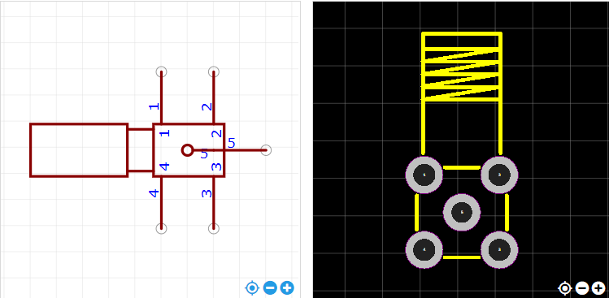
https://item.szlcsc.com/985455.html

